Neural Networks were originally created to mimic the architecture of the brain and its neurons. They are powerful systems that can find deep representations and patterns in structured, unstructured, and semi-structured data. They also require large datasets and computational power to learn and perform at their best. Neural Networks are fundamental building blocks of deep learning. They are used in NLP, Computer Vision, and autonomous systems.

Neurons, otherwise known as Perceptrons in deep learning, are made up of a few things. It starts with receiving inputs, this could be any data that it needs to learn complex patterns from. Then it applies weights, weights are what the NN uses to record the patterns and similarities that it finds between data points. Next it adds bias, bias helps the model learn even when all input features are zero. Then finally the activation or activation function. This is the final calculation that introduces non-linearity in the model allowing it to derive complex representations. The structure of these neurons is input layer, hidden layers, then output layer. The input layer is what accepts the data and passes it to the first hidden layer. The hidden layer extracts features then passes the data along to either the next hidden layer or the output layer. The output layer is for final predictions by our model. Before the data can be output though it must have an activation function added to it before we can use the output.

The Neural Network zoo is simply a depiction of different neural networks as animals in a zoo.

* Convolutional Neural Network is a Cheetah.
* Recurrent Neural Network is a Penguin.
* Transformers are Gorillas.
* ResNets or Residual Networks are Elephants.
* U-Nets are Gazelles.
* GANs or Generative Adversarial Networks is a Parrot
* VAEs or Variational Autoencoders are Zebras

**Zoo: Visual Chart**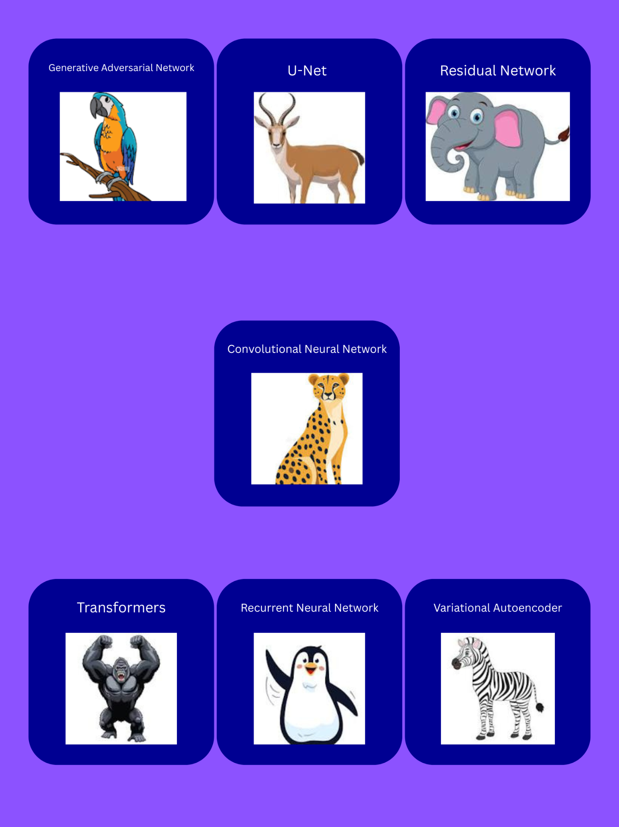

**Neural Network Animal: Digital Illustration Poster**